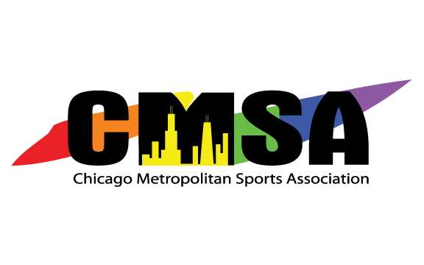

2019-2020
Board of Director’s Meeting Minutes
November 4, 2019
7:00 pm
Location: Center on Halsted
3656 N Halsted St, Chicago, IL 60613

Name | Board Position | Attended?
Matt Herek | President | Yes
Jay Gonnam | Vice President | Yes
Lindsay Frounfelkner | Vice President | Yes
Brandon Knop | Secretary | No
Michael Rice | Treasurer | Yes
Christina Federighi | Director at Large | No
Matthew Graham | Director at Large | No
Paul Johnson | Director at Large | Yes
Myles Lawter | Director at Large | Yes
Chris Rinere | Director at Large | Yes
Zack Zusag | Director at Large | Yes

Call to Order

PRIOR MEETINGS:
- Approval of Agenda:
  - Approved.
- Approval of Minutes:
  - Approved, with comments.

PRESENTATIONS:
- Amita Health – Sam Cochran
  - Presented a free benefit to CMSA members from Amita Health
  - Benefit is a sports medicine outreach program which provides a number to assess injuries and direct the player to the best care location (or self care)
  - Can partner with us in the future for health education programs
- Softball Pride Tournament – Mark Sakalares
  - Proposal for national softball tournament, June 25 & 26 at Horner Park
  - NAGAAA has requested Chicago, no tournaments in June nationwide
  - Budget projections provided with projected profit for first year and beyond
  - Tournament to be run by independent committee including Tournament Director and Finance Chairmen
- CMSA Hall of Fame – Brian Kupersmit
  - Raised potential opportunities for additional CMSA awards
  - Budget of $2,000 requested
  - Survey will go out in mid-November related to awards
- CMSA Badminton – Not present

OFFICER/COMMITTEE REPORTS:
- President
  - Proposed undertaking a plan for dealing with weather contingencies on an overall CMSA basis
- Vice President – Athletics (Marketing Committee)
  - Women’s softball is completing its season this week; partial refunds will be issued for weather once all money is collected
  - Kickball is also completing its season; commissioner is looking at finding new fields for fall 2020 league
- Vice President – Operations (Events Committee)
  - Discount code for ZooLights “Holidaze” Adults Night Out has been secured for 20% off admission on December 5th
  - Looking into participation for Bulls Pride Night on January 4th
  - Looking into possible other venues for Annual Party, however the other options will likely be pricey, so it will most likely remain at Cubby Bear, at least for one more year
- Website Committee
  - Survey feedback
    - People want simple, fast, informative
    - People want schedules & registration in one place
    - People are interested in participating in focus groups
    - Next Steps, preparing for quote, information packets from sports leagues, preparing focus group materials
- Treasurer
  - Commissioners seem to be more mindful and more accurate with budgets this year

UNFINISHED BUSINESS:
- eSports
  - Kickoff event will be December 5 at Replay Lincoln Park
    - Games to be determined, drink specials provided by bar
    - 10 week season suggested, team sizes TBD
  - Motion: Herek, Second: Frounfelkner: $1,000 seed money allocated to eSports league. Approved.
- CMSA Awards
  - Ideas include: League of the Year, Ally of the Year, Athletes of the Year (3), Volunteer of the Year
  - Ideas will be further discussed before moving forward
- New Member Gifts
  - Onboarding or welcome gifts are a potential idea

NEW BUSINESS:
- Holiday Cards/Gifts
  - Signing/wrapping will take place at next board meeting

ANNOUNCEMENTS:
- Zusag is still working on further analytics; running into issues with customer service at LeagueApps
- Next meeting will be a working session on November 3, 2019 at 7:30 PM. Location TBD.

Adjourned

