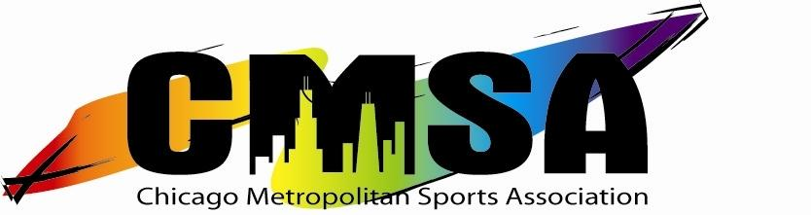
2011 – 2012

3023 N. Clark Street - #806 – Chicago, IL 60657 – (312) 409-7932
www.ChicagoMSA.org

Board of Directors – MINUTES
Wednesday July 18, 2012
7:00 pm – 9:45 pm
Margate Field House
4921 N. Marine Dr.
Chicago, IL 60613

ATTENDEES:

Name | Board Position | Attended?
Shawn Albritton | President | Yes
Mark Sakalares | Vice President | Yes
Brian Kupersmit | Vice President | Yes
Matt Simpson | Secretary | Yes
Marcia Hill | Treasurer | Yes
Jaz Aguilar | Director | No
Jason Kallen | Director | Yes
Michael O. Rice II | Director | Yes
Andrew Burke | Director | Yes
Chris Jessup | Director | Yes
Brian Lopez | Director | Yes

Shawn A. called the meeting to order at 7:00 pm.

PRIOR MEETINGS:

- Mark S. motioned to approve the prior minutes. Marcia H. 2nd. Motion carried.
- Mark S. motioned to approve the agenda. Marcia H. 2nd. Motion carried.

Board of Directors – MINUTES
Thursday, July 18, 2012

SPECIAL BUSINESS:

- Shawn A. turned the meeting over to Mark Sakalares.

- Mark explained the rules of the election.

- Each candidate was allowed to speak for 2 minutes, with 3 minutes for questions and answers.

- The candidates were as follows:
- Veronica Hernandez
- Michael O. Rice II
- Yvonne Lopez
- Brian Kupersmit
- Kristen Polich
- C.J. Winke
- Steve Whitley
- Jessica Andrasko

- The election began with the following results by round:

- Round 1: Brian Kupersmit and Michael O. Rice II received the required amount of votes to be elected to the board of directors. Yvonne Lopez had the lowest vote total and was dropped from the ballot
- Round 2: No candidate received the required number of votes. C.J. Winke had the lowest vote total and was dropped from the ballot
- Round 3: No candidate received the required number of votes. Veronica Hernandez had the lowest vote total and was dropped from the ballot
- Round 4: No candidate received the required number of votes. Steve Whitley and Kristen Polich tied for the lowest vote total. No candidates were dropped from the ballot.
- Round 5: No candidate received the required number of votes. Steve Whitley had the lowest vote total and was dropped from the ballot.
- Round 6: Jessica Andrasko received the required amount of votes to be elected to the board of directors for the 3rd and final open position.
- The election was declared over.

Board of Directors – MINUTES
Thursday, July 18, 2012

- The 3 winning candidates (Brian Kupersmit, Jessica Andrasko, and Michael O. Rice II) joined the holdover officers (Mark Sakalares and Matt Simpson) to vote on who would hold what position. Outgoing President Shawn Albritton oversaw the election.
- Brian Kupersmit was elected President
- Mark Sakalares and Jessica Andrasko and were elected Vice President 1 and Vice President 2 respectively.
- Michael O. Rice II was elected Treasurer.
- Matt Simpson is the secretary.

- Brian Kupersmit addressed the meeting and announced that an e-mail would be forthcoming giving members information on how to apply for one of the six board director positions.

NEXT MEETINGS:

- Board Meeting: 7/30/12 at 7:00, place TBD

MOTION TO ADJOURN:

- Mark S. motioned to adjourn.
- Matt S. 2nd.
- Motion carried, meeting adjourned at 9:45

